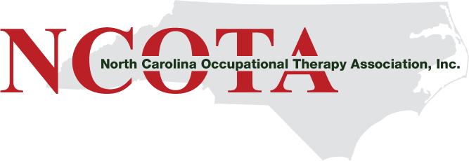
2019 Annual Conference
“ Connecting the Dots: Building Connections for Everyday Leadership”

Saturday November 2, 2019
The McKimmon Conference and Training Center at
North Carolina State University
Raleigh, NC 27606

PO Box 20432 Raleigh NC 27619
www.ncota.org Email: office@ncota.org

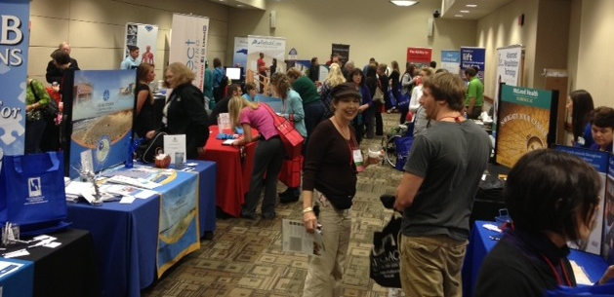

The North Carolina Occupational Therapy Association’s Annual Conference is the place to gain a strong position in the North Carolina occupational therapy market and to interact face-to-face with hundreds of practitioners. The NCOTA 2018 Fall Conference had a busy and dynamic exhibit hall with over 15 exhibitors, and the location for 2019 Fall Conference will bring practitioners from all across North Carolina. Participating exhibitors have opportunities to interact with occupational therapy practitioners and students seeking information about career opportunities, product and service information, as well as an opportunity to create meaningful connections with vendors and organizations promoting the profession of occupational therapy.

For over 60 years, NCOTA has provided continuing professional education, advocated for practice and the profession, and fostered the occupational therapy community in North Carolina.

Promote your Business or Product & Support Occupational Therapy through:
- Onsite Exhibits
- Advertisements in the Conference Program
- Breaks & Special Events Sponsorship

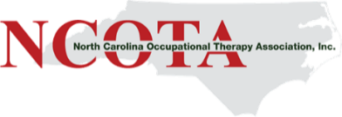

Exhibitor Registration:
For each exhibitor space secured, you may register up to 2 representatives as exhibitors. Exhibitor registration entitles your representatives to enjoy lunch and all break services offered to attendees. Registered exhibitors may not attend other conference events, including educational sessions, unless they have registered for the conference.
NCOTA Conference Registration:
Each exhibitor is also able to register one representative to attend the educational sessions at a 25% discounted rate. If representatives want to attend the conference program, email us and we will provide instructions.
*When registering online, choose the “speaker” ticket as it will automatically include the 25% discount. Continuing education credit is only awarded to registered conference attendees.

Advertise In the Conference Program:
The NCOTA Conference Program is used by attendees throughout the conference. But it is not discarded afterward! The conference program includes descriptions of educational sessions, the certificate of attendance, and the attendee’s record of education sessions attended. Attendees retain the program for their records of continuing competency activities. Please check preferred option and send a copy ready graphic to office@ncota.org by June 30, 2019.

 | Before August 1 | After August 1
Exhibit Space | $345.00 | $375.00
Advertise in Program | Deadline July 30
Half-Page | $250.00
Full-Page | $500.00
Sponsorship Levels
Platinum Sponsor – Includes company logo on Conference Bag, full-page ad in conference guide, company logo in conference email, recognition during Welcome Session plus two-minute spotlight for representative to address attendees in Saturday morning general session. | $2,500
Gold Sponsor – Includes half-page ad in conference guide, logo in conference email, and recognition during Welcome Session. | $1,500
Silver Sponsor – Includes company logo in conference email and recognition during Welcome Session. | $1,000
Lunch Sponsor – Includes half-page ad in conference guide, recognition signage on lunch tables, plus 1-min spotlight at beginning of lunch to address attendees. | $950
Assistive Technology Competition Sponsor – Includes recognition signage, half-page ad in conference guide, and 1-minute spotlight at competition. | $750
Snack Sponsor – Recognition signage and half-page ad in conference guide. | $550
To select one or more of the options above, please visit the NCOTA website (www.ncota.org) and click on the “Conference” link to fill out the online registration form. Alternately, you can indicate your choices on contract page (5) and send with payment.

Contract-Exhibit Space

The undersigned, by its duly authorized officer, agent or employee (therein after called “Exhibitor”) hereby enters into a contract with the North Carolina Occupational Therapy Association, Inc. (hereinafter called NCOTA) for exhibit space at the NCOTA 2019 Annual Conference, to be held on November 2, 2019 at The McKimmon Conference and Training Center in Raleigh, NC. This contract is subject to (1) acceptance by NCOTA and (2) such additional terms and conditions which constitute a part of, or are included in, this contract. Reservation of exhibit space by NCOTA on behalf of the Exhibitor is conclusively presumed to be adequate consideration to bind the Exhibitor. No contract is final until payment is received in full.

Terms and Conditions:
Payment terms: Payment is due upon submission of contract by check (made payable to NCOTA, Inc.) or credit card. Contract is not valid until accepted by NCOTA.
Time: Saturday, November 2, 10:00 am - 7:30 pm.
Set-up: Saturday- 10:00 am
Removal: Saturday- 7:30 pm for all Exhibitors.
Space: (2) chairs, and (1) 8-foot draped and skirted table.
Space assignment/positioning: Booths are not pre-assigned. All spaces have comparable exposure.
Safety: Exhibitor agrees to comply with fire, safety and health regulations of the convention center and the local municipality.
Liability: Neither NCOTA, nor the conference facility, nor any NCOTA member or representative shall be responsible for any injury, loss or damage that may occur to the Exhibitor or the representatives of the Exhibitor or his or her property from any cause whatsoever prior to, during, or subsequent to the period covered by the exhibit space contract. The Exhibitor agrees to indemnify NCOTA, the conference facility and NCOTA representatives against any claims for such loss, damage or injury.
Electrical/communication connections: Electrical, phone or wired internet connections may be arranged through communication with NCOTA conference planning team. Services must be secured by completing the utilities and/or internet services forms in the exhibitor prospectus.
Drayage services: Box and pallet shipping/receipt/storage must be arranged directly. No receiving, storage, or shipping services shall be arranged by NCOTA.
Exhibitor Registration: For each exhibit space secured, 2 representatives may be registered as exhibitors. Exhibitor registration entitles representatives to the food and beverage services offered in the exhibit area. NCOTA shall issue badges to registered exhibitors at onsite check-in. Only registered exhibitors shall be permitted in the exhibit area during setup and breakdown/removal of exhibits. Only registered exhibitors/representatives are permitted to staff exhibit spaces. Registered exhibitors may attend special events only upon payment of the relevant special event fee. Exhibit registration is separate from conference registration. Registered exhibitors are not permitted to attend educational sessions unless conference registration has also been paid (see below).
Conference Registration: Each exhibiting organization is entitled to one discounted conference registration. Occupational therapists, occupational therapy assistants and occupational therapy students must register to attend any conference sessions or events. Continuing education credit is awarded only to those who have registered for conference. *Choose “speaker” ticket as it will automatically register the 25% discount.
Literature/materials distribution: Literature and other materials may be distributed from the contracted exhibit space. No materials may be placed on meeting room seats or attached to walls.
Raffles: Raffles or drawings may be permitted in the exhibit area by individual Exhibitors if prior permission is granted by NCOTA. A written request to conduct a raffle must be submitted to NCOTA stating the type of gifts or prizes to be raffled. Sales: Any Exhibitor who intends to offer anything for sale shall inform NCOTA, upon signing the contract, of the products and services that will be offered for sale. NCOTA reserves the right to reject an exhibit contract upon receipt of the products and services that will be offered for sale by an Exhibitor are not of a professional nature. NCOTA has the sole discretion in determining what constitutes undesirable sales. Exhibitors are solely responsible for obtaining all licenses and permits required by the city, county and state and for payment of all taxes.
Food/beverage restrictions: Items such as candy for giveaways are permitted, but no food or beverage items may be distributed or sold in the exhibit area other than those arranged by NCOTA and distributed by the Conference Center.
General restrictions: Exhibitors must confine their activities to their contracted space. Exhibitors are not permitted to use strolling entertainment or to distribute samples, literature or promotional items except from their contracted space. For each exhibit space contracted, a maximum of two (2) representatives may work at any one time. Exhibit spaces may not be used as a meeting or gathering place during exhibit hours. Employees or associates of the Exhibitor who are registered for conference but not registered as exhibitors are permitted to substitute for registered exhibitors for brief periods to ensure adequate staffing. These substitutions must adhere to the two (2) person maximum per space at any one time.
Cancellation: In the event the Exhibitor cancels all or part of the exhibit space contracted herein, the Exhibitor must do so in writing by certified mail (NCOTA, PO Box 20432 Raleigh, NC 27619-0432) and will be obligated to pay to NCOTA liquidated damages based on the following schedule: Prior to September 1, 2019- 0% liability, September 2-October 10, 2019-50% liability, On or after October 10, 2019-100% liability. All services and benefits shall be forfeited with the cancellation of space.

Name of Company/Organization:

Signature of Authorized Representative, ACCEPTANCE AS BINDING CONTRACT:

Company Name
Contact Person
Full Mailing Address
Email
Name & Cell of Representative(s) Attending
Fax #

Our Company/Organization will: |  | Company Rep Initials | Cost (see pg. 2)
 | Advertise in Program – Indicate Size: |  | $
 | Exhibit Onsite |  | $
 | Sponsorship Level – Indicate Level: |  | $
Total Cost |  |  | $
Small non-profit organizations have the option of reserving an exhibit booth at a 25% discounted rate. Non-profits complete this section to receive a discounted booth space. To qualify for discount, organization must be a 501(c)(3) non-profit corporation with 25 or fewer employees.
Does the organization have 501(c) (3) (charitable, scientific or educational) IRS status? Yes or No?
Number of employees:

Payment Information (fill in below)
MasterCard/Visa # | Exp. Date: | Security Code | Name as appears on card |  | Billing Zip: | Email address for receipt
I authorize NCOTA to charge the above card in the amount: |  | $ |  | Signature:

